A) SALESPEOPLE

Snum int(4)

Sname varchar(10)

City varchar(10)

Comm float(3,2).

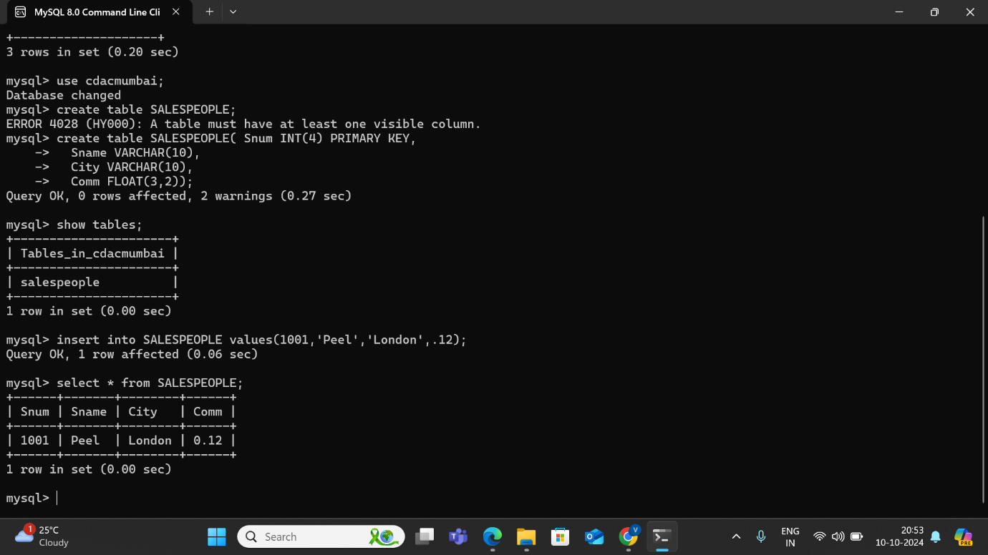

B) CUSTOMERS

Cnum int(4)

Cname varchar(10)

City varchar(10)

Rating int(4)

Snum int(4).

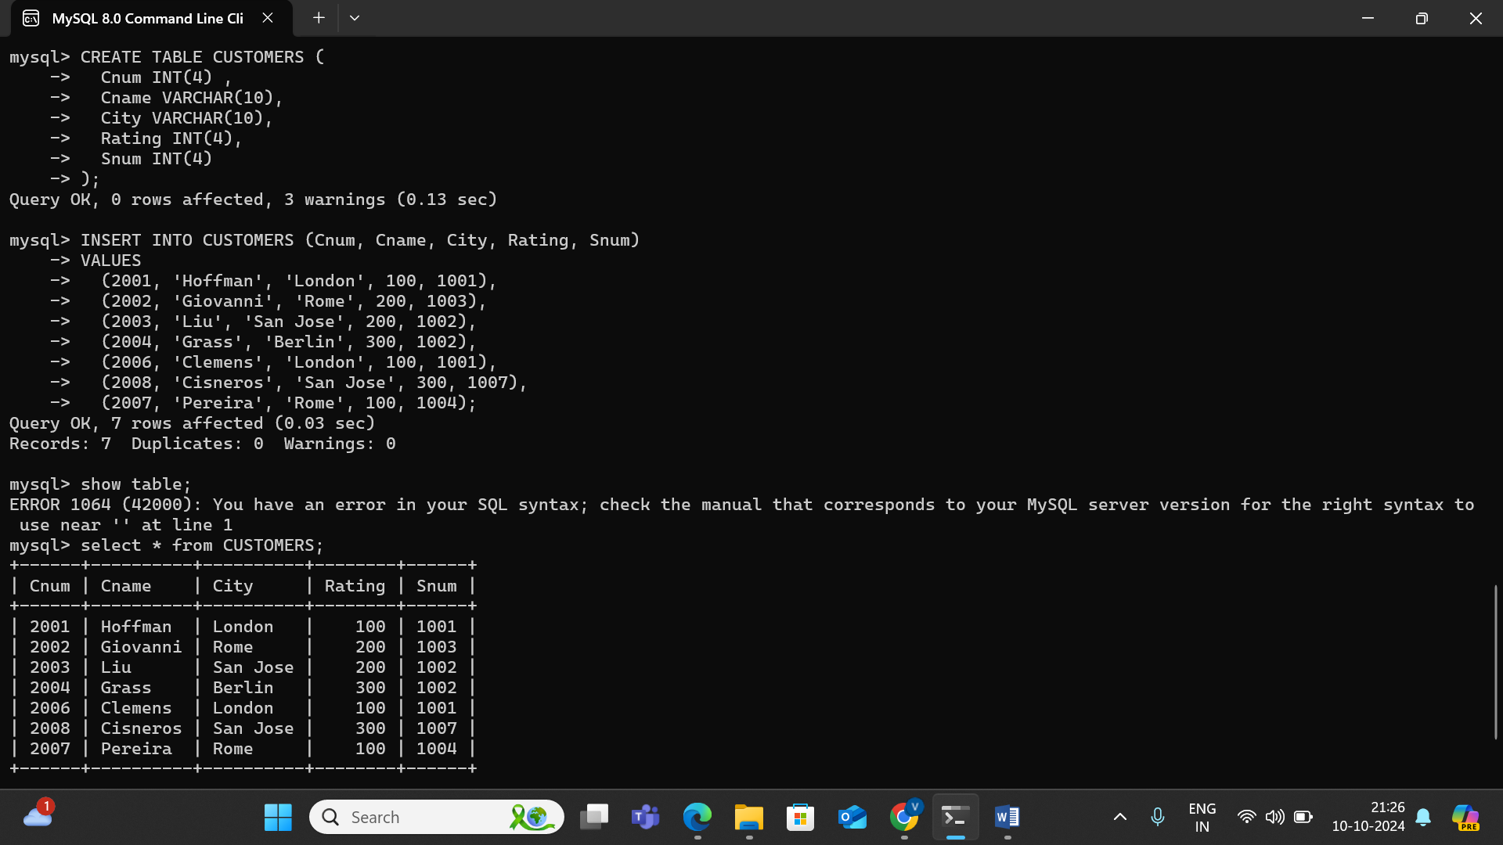

C) ORDERS

Onum int(4)

Amt float(7,2)

Odate date

Cnum int(4)

Snum int(4)

